What is face land mark estimation?

Identify key pint on the face – tip of the nose , center of the eye

Ex-  
Before and after using land mark detection –

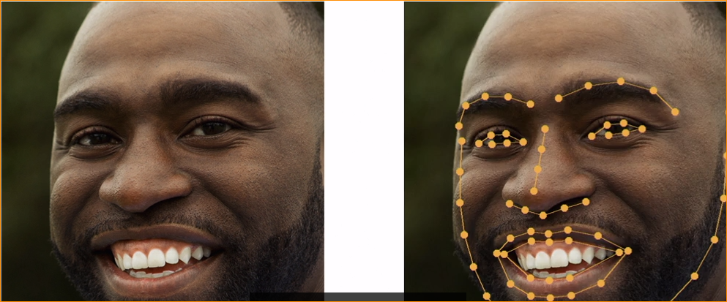

Each point call –face land marks

In here located eye brows , eyes ,nose, lip and chin line.

This particular landmark estimation model is call 68 point landmark model.

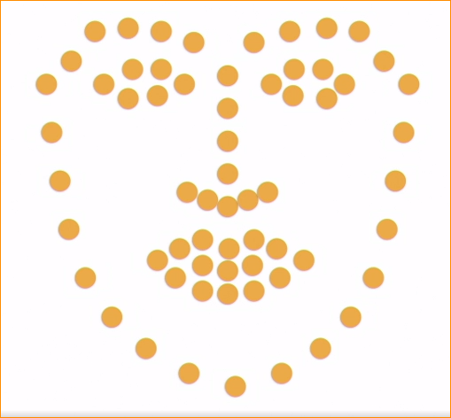

To do quick this process , some model reduce ponint

Ex- 5 point model –

It only detects the edges of each eye and the bottom of the nose.

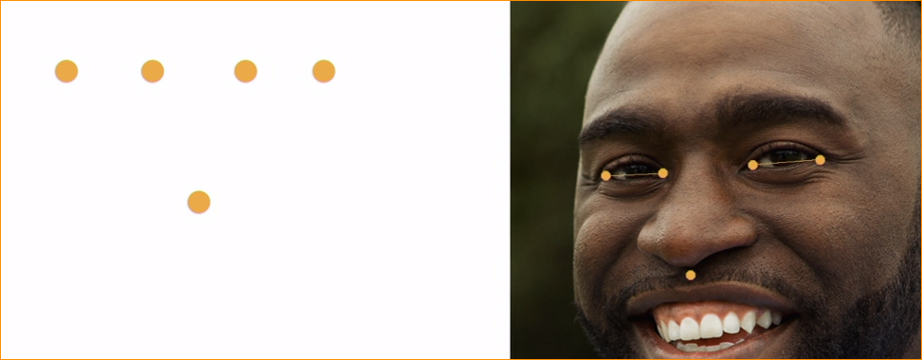

Some application five point enough. Some time not. 5 point- work quickly.

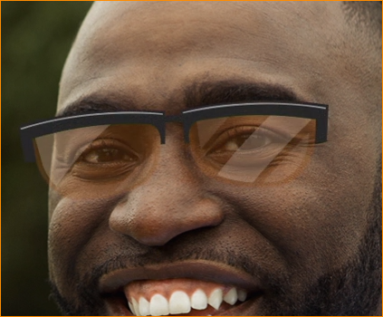This use mostly social media lenses.

Simply detect eyes and put sunglasses.

**Identifying Face Landmarks with a Machine learning model**

Understand face and put each point using computer is very difficult. There are trickes

***Trick 01 – Assume All faces default close is same shape.***

I am saying points should adjust point to the face, like this –

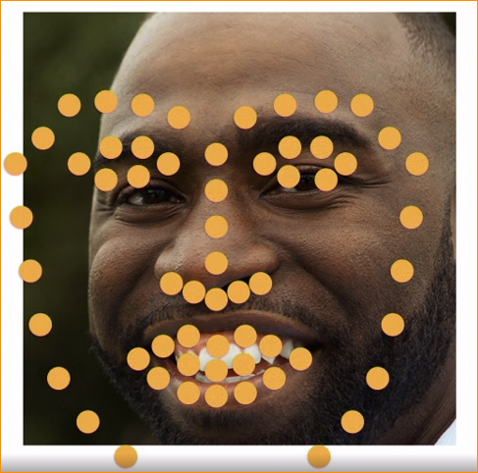

***Trick 02 – Limit movement of each point***

How much computer can movie each point.

No single point can be move too far from its neighboring points.

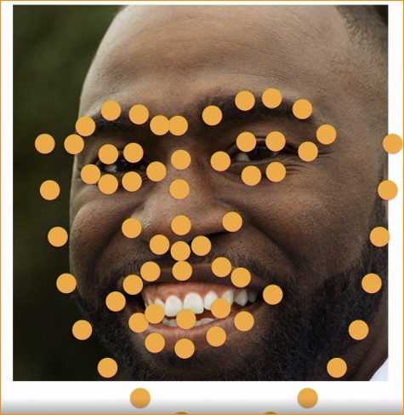

In here as the example – nom point moves too far from its neighbor points.

***Trick 03 – Fine-Tune with Multiple Models***

We train several different ML models that each do part of the job.

First model is allowed to move the points a good bit. It just has to improve the fit over the starting point.

Again give right tune for the model. Each point less than 1 st model.

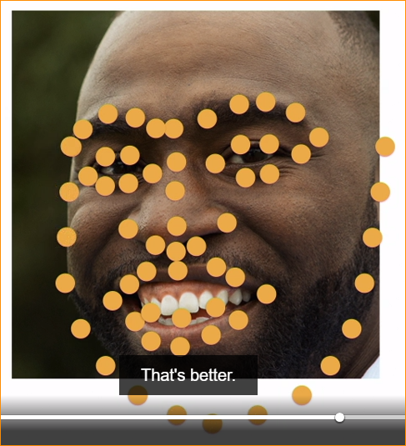

Second model – has to learn how to fix the mistakes of the first model.

This process doing one model result feeding other model result. This should continuous many as 10 times.

The end result of all 10 models that points end up in exactly the right place

And once this cascade to face landmark model is trained, it should work any place. For this we can use pre train models.

Limitations – model train human faces not cartoon faces.

If you want use cartoon data for training data.

**Posing Faces Base on Face Landmarks**

Face Alignment – Adjusting a raw face image so that key facial features (Like eyes, nose and mouth) lineup with a predefined template.

* Why do we need a align Face Images ?

We want the persion recognition system work even person not looking directly to the camera.

Diffetent people rotate head different ways in different photos

Correcting for head angle and rotation will make our face recognition system more accurate.

**Step 01 – Detect face landmarks**

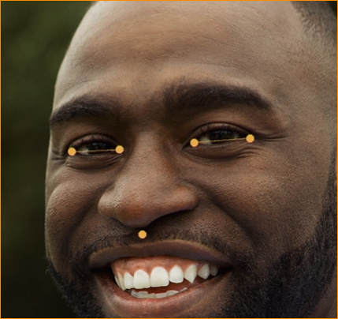

In here we detected 5 key points (nose tip and size of eye  
)

**]**

**Step 02 – Calculate affine Transform**

Adjust the image on the points.

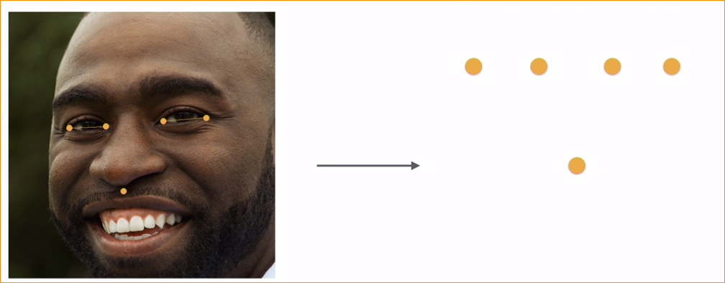

Affine transformation – a linear mapping between sets of points where parallel lines will remain parallel.

This means we can rotate and stretch our image, but not do complex things. Like twisting or warping the image.

To affine transformation –

Figure out what amount of stretching and rotation would get them closet to the points on the right.

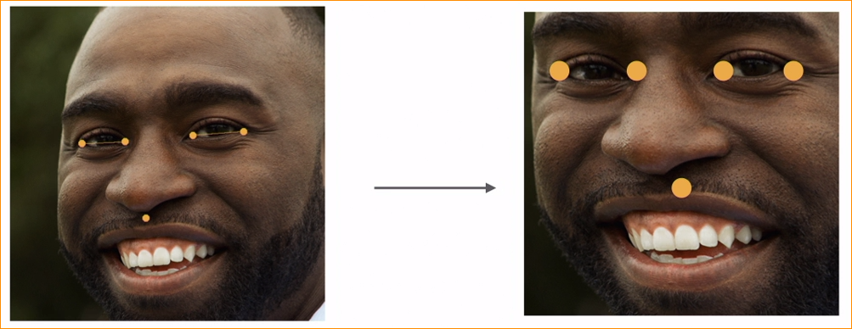

Original photo vs Template

The use the same math’s to the pixels in our image.

Face recognition library doing face alignment staff for us.

If system can not recognize the five point of image, that system wont work our image.

Code –

‘Recognize individual land marks –



Install pillow library

Take image class and Image Draw calss

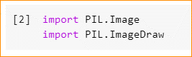

Install and import face recognition library.

This is give access to the face landmark detection model.





Load the images and run the images in the two models-

1. Model 01 – face land marks model

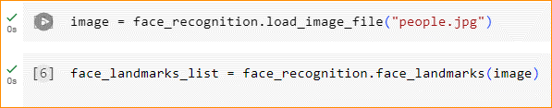

In here key are the dictionary of facial feature. Things like the left eye, right eye ,chin and so on.

Value of each key of X,Y coordinates of the points. That correspond to that facial features.

Example – each eye is list of six points that trace a line from one end of the eye to another.

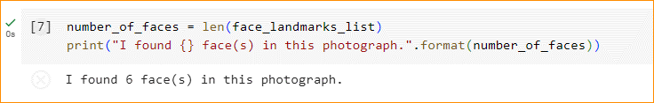

In here we check the length of the list. And how many faces we found the image.

Convert image to PIL format-



Image draw the top of image, use it to draw the lines for each facial feature.



Loop through the list of features. See what found each face-

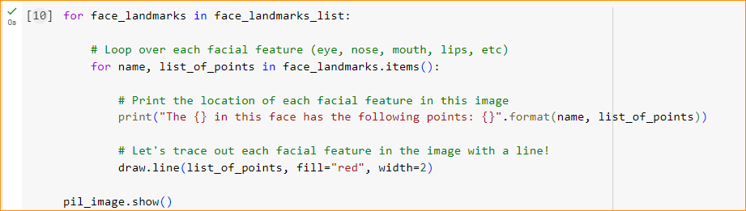

Each entry will have name and value,

Name and list of points get and print that data

And draw a line representing the facial feature we found.

The PIL line function just requires alist of points to draw so pass that directly- line color red, width 2px

We can see facial features and coordinates. This is lot easy to visualize lines on the image.

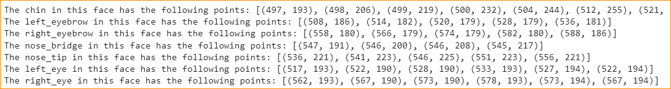

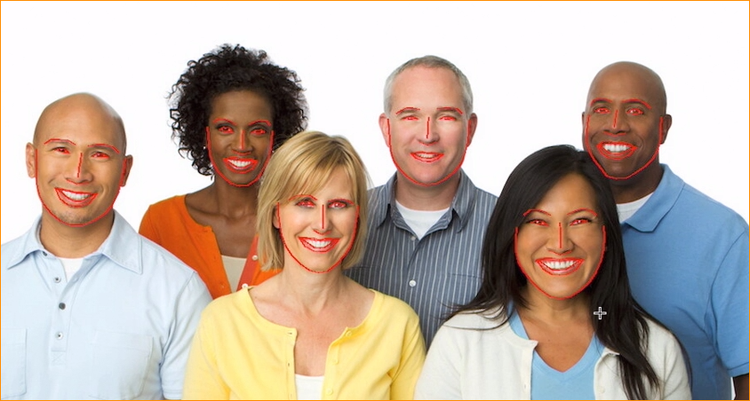

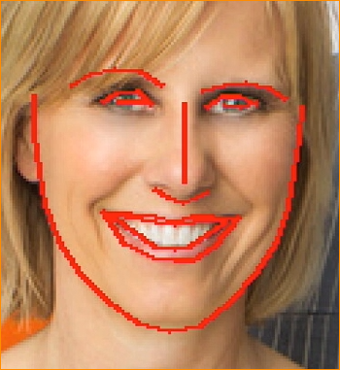if we zoon, if found lips, mouth eyes nose and eye brows